Online Restaurant Menu using HTML, CSS, and JavaScript

🎯 **Aim**

The aim of this project is to design and develop a user-friendly, visually appealing online restaurant menu using only front-end technologies such as HTML, CSS, and JavaScript. This menu should serve as a digital alternative to traditional printed menus, offering customers a more interactive experience. The application will categorize dishes under headings like Starters, Main Course, and Desserts, with each item featuring an image, a bold title, and a short, enticing description. The project emphasizes responsive layout, clean organization, and aesthetic styling using CSS, as well as the use of basic JavaScript for enhancing interactivity—such as highlighting the selected menu category.

This project also aims to help beginners and students build a strong foundation in front-end development by applying key web development concepts in a real-world scenario. By the end of this project, users will have a functional and stylish menu that could be integrated into a restaurant's official website or used as a standalone web application.

**🎯 Objective**

* To create a digital menu layout with categories such as Starters, Main Course, and Desserts.
* To display food items using ordered and unordered lists.
* To include images and short descriptions for each dish.
* To apply CSS styling for better visual appearance.
* To use JavaScript for basic interactivity such as highlighting selected categories.

**🛠️ Project Steps**

1. **Create the basic structure using HTML** with sections for each food category.
2. Use **Ordered List (OL)** to define main categories like Starters, Main Course, and Desserts.
3. Use **Unordered List (UL)** under each category to list individual food items.
4. Add **images and descriptions** for each food item.
5. Style the menu using **CSS** to include background images, colors, borders, and hover effects.
6. Write simple **JavaScript** to highlight the active category when clicked.
7. Test the design across screen sizes to ensure basic responsiveness.

**💻 Code**

**✅ HTML (index.html)**

<!DOCTYPE html>

<html lang="en">

<head>

<meta charset="UTF-8" />

<meta name="viewport" content="width=device-width, initial-scale=1.0"/>

<title>Online Restaurant Menu</title>

<link rel="stylesheet" href="5.css" />

</head>

<body>

<header>

<h1>Welcome to JAAT Restaurant!</h1>

<p>Explore our desi menu below</p>

</header>

<main>

<ol>

<li onclick="highlight(this)">Nashta</li>

<li onclick="highlight(this)">Mukhya Bhojan</li>

<li onclick="highlight(this)">Misthan Bhandar</li>

</ol>

<section class="menu-section" id="Nashta">

<h2>Nashta</h2>

<ul>

<li>

<img src="https://static.toiimg.com/photo/53109843.cms" alt="Aloo Ke Paranthe" />

<p><strong>Aloo Paranthe</strong><br> Swadisht Aloo ke paranthe with Dahi.</p>

</li>

<li>

<img src="https://www.eatingwell.com/thmb/BFKxRmk1Julcr1ldWafGvzVChxk=/1500x0/filters:no_upscale():max_bytes(150000):strip_icc()/chole-bhature-beauty1x1-921-f66fc717da044251be01feb1cd0dba3e.jpg" alt="Chole Puri" />

<p><strong>Chole Puri</strong><br> Mast Puri with chole.</p>

</li>

</ul>

</section>

<section class="menu-section" id="Mukhya">

<h2>Mukhya Bhojan</h2>

<ul>

<li>

<img src="https://www.vanillabeancuisine.com/wp-content/uploads/2024/12/Spaghetti-Alfredo-2nd-Set-7.jpg" alt="Dal Roti and Dal Chawal" />

<p><strong>Dal Roti and Dal Chawal</strong><br> Proper Desi .</p>

</li>

<li>

<img src="https://www.allrecipes.com/thmb/Bw4L_IuQHhHeqq52cEkWbA5PIGo=/0x512/filters:no_upscale():max_bytes(150000):strip_icc()/16160-juicy-grilled-chicken-breasts-ddmfs-5594-hero-3x4-902673c819994c0191442304b40104af.jpg" alt="Grilled Chicken" />

<p><strong>Grilled Chicken</strong><br> Juicy grilled chicken served with rice.</p>

</li>

</ul>

</section>

<section class="menu-section" id="Misthan">

<h2>Desserts</h2>

<ul>

<li>

<img src="https://www.indianhealthyrecipes.com/wp-content/uploads/2024/06/classic-chocolate-cake-recipe-500x500.jpg" alt="Chocolate Cake" />

<p><strong>Chocolate Cake</strong><br> Rich and moist chocolate layered cake.</p>

</li>

<li>

<img src="https://encrypted-tbn0.gstatic.com/images?q=tbn:ANd9GcToNb4qLVc8li_M2NHBfEl14DaVpUCmplY5lg&s" alt="Ice Cream" />

<p><strong>Vanilla Ice Cream</strong><br> Classic creamy vanilla flavor.</p>

</li>

</ul>

</section>

</main>

<script src="1.js"></script>

</body>

</html>

**🎨 CSS (5.css)**

* {

box-sizing: border-box;

margin: 0;

padding: 0;

}

body {

font-family: 'Segoe UI', sans-serif;

background: url('https://t3.ftcdn.net/jpg/02/05/87/60/360_F_205876015_hYYs7ugqoU8QAobSS3TbnGQ92qyS5gEc.jpg');

background-color: #fff8e1;

color: #333;

}

header {

background-color: #ff7043;

padding: 20px;

text-align: center;

color: white;

}

ol {

display: flex;

justify-content: center;

background-color: #ffe0b2;

padding: 10px;

list-style-position: inside;

font-weight: bold;

cursor: pointer;

}

ol li {

margin: 0 15px;

padding: 10px 20px;

border: 2px solid transparent;

border-radius: 10px;

transition: 0.3s;

}

ol li:hover, ol li.active {

border-color: #ff5722;

background-color: #fff3e0;

}

.menu-section {

padding: 20px;

}

.menu-section h2 {

margin-bottom: 15px;

color: #e64a19;

}

.menu-section ul {

display: flex;

flex-wrap: wrap;

gap: 20px;

list-style: none;

}

.menu-section ul li {

background-color: #fff3e0;

border: 1px solid #ffccbc;

border-radius: 10px;

padding: 10px;

width: 200px;

text-align: center;

}

.menu-section img {

width: 100px;

height: 100px;

border-radius: 50%;

}

**✨ JavaScript (1.js)**

function highlight(element) {

const items = document.querySelectorAll("ol li");

items.forEach((item) => item.classList.remove("active"));

element.classList.add("active");

}

**🖼️ Output**

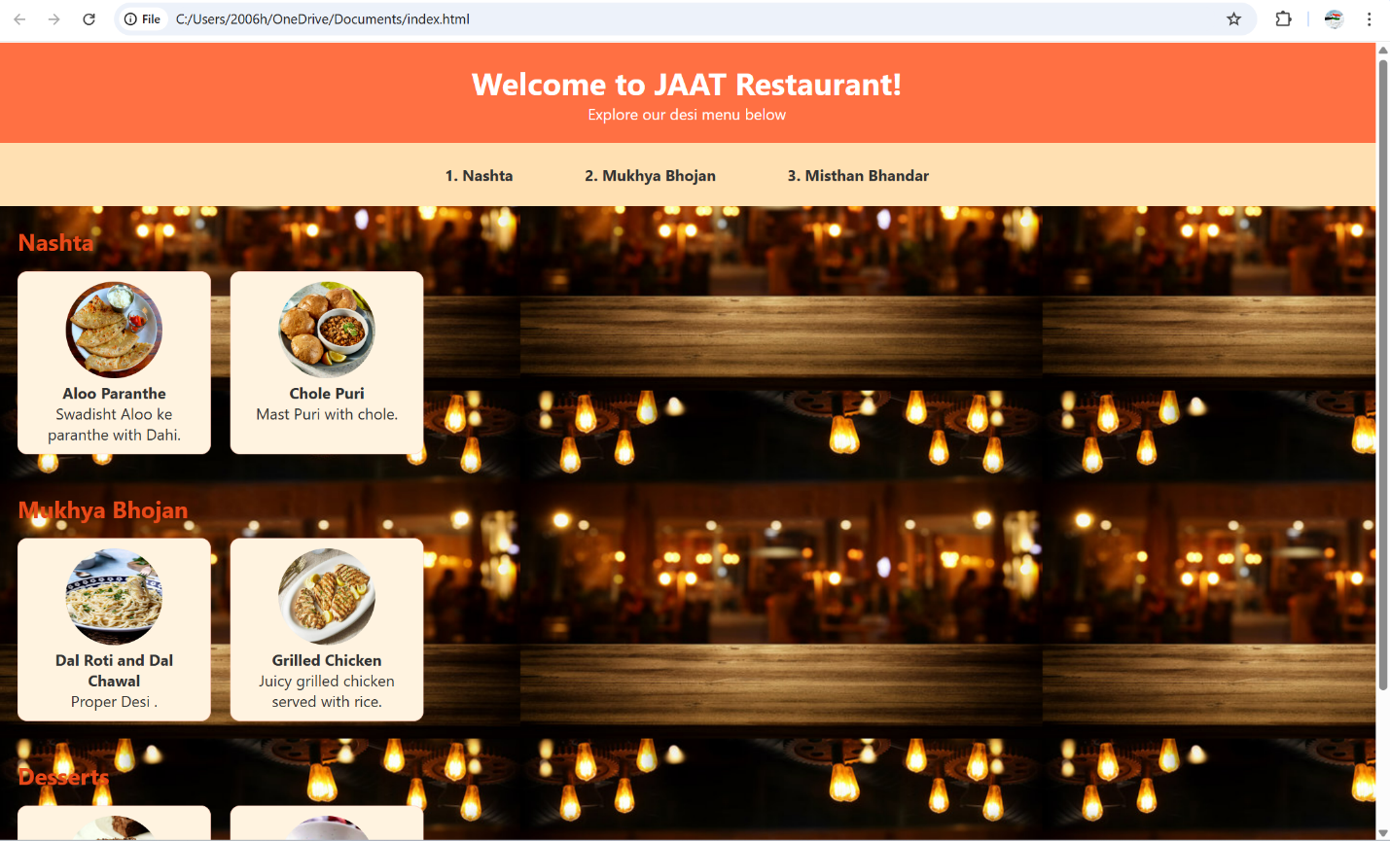

**🎓 Learning Outcomes**

By completing this project, students will:

* Understand and implement **semantic HTML structure**.
* Use **ordered and unordered lists** for categorizing content.
* Apply **CSS for styling**, including borders, background images, and hover effects.
* Use **JavaScript for DOM manipulation** and adding basic interactivity.
* Design a visually appealing web page that mimics real-world applications.
* Gain experience in **frontend web development fundamentals**.